Chapter 14, Solution 65.

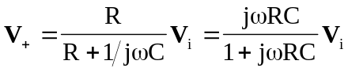

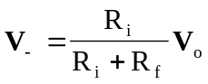

Since 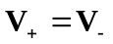,
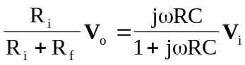

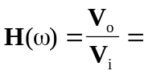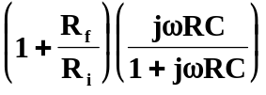

It is evident that as , the gain is 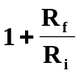 and that the corner frequency is 

